

**CAPSTONE PROJECT UNDERTAKING**

I, **Manahan, Dionell J.**, a student of the College of Information Technology and Computer Science – University of the Cordilleras, hereby state:

1. that I am enrolled in capstone project for the second trimester of school year 2023-2024;

2. that the second trimester of school year 2023-2024 started on January 6, 2025 and will end on April 15, 2025;

3. that as a capstone project student, I am expected to comply with the weekly deliverables expected from me;

4. that I must defend my study and submit all needed documents on or before April 15, 2025;

5. that if I fail to defend my study and submit all needed documents (despite the interventions of my adviser) after April 15, 2025, I shall get a grade of INC;

6. that I shall NOT INSIST AND DEMAND that I be given a completion grade before April 15, 2025; and

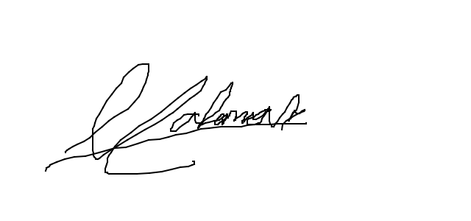7. that I fully understand this undertaking, take full responsibility of my actions (as a result of not heeding the interventions of my adviser), and will not blame the faculty members and the College of my failure to meet the capstone project requirements.

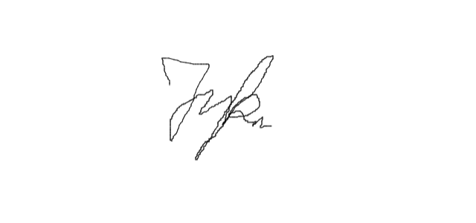**Manahan, Dionell J.**

CITCS Student

Noted:

**Kalagui, Jerol J.**Parent/Guardian

Contact Number: 09123667355